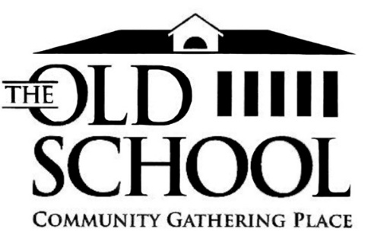

## Notice of Annual General Meeting and Call for Board Nominations

Issued on July 21, 2025

Dear Members,

In accordance with Clause 9(a) of our bylaws notice is hereby given that the Annual General Meeting (AGM) will take place as follows:

**Date: Thursday, July 31, 2025**

**Time: 6:00 p.m. – 8:30 p.m.**

**Location: The Old School, 7962 Highway 7, Musquodoboit Harbour**

The agenda for the AGM is attached to this notice. All current members are encouraged to attend and participate. (A 10% quorum of current members is required for the meeting to proceed.)

**Renewal of annual membership**

If you have not already done so, please renew your membership prior to the meeting. Please go to [www.oldschool.ca](http://www.oldschool.ca) and click on the MEMBERSHIP tab for instructions. If you pay via electronic transfer, please make sure to stipulate that it is your membership renewal, or we may not be able to update your membership status.

## Call for Expressions of Interest: Board of Directors

The Old School is seeking expressions of interest from members who wish to be considered for election to the Board of Directors. This is an opportunity to play an active role in shaping the future of our organization.

We are particularly looking for individuals who:

* Are representative of our communities
* Have a financial or accounting background
* Bring experience or interest in governance of not-for-profit organizations
* Are committed to community development and engagement
* Offer skills in public relations or marketing
* Have experience in strategic planning and negotiation
* Are comfortable with documentation and record keeping

AND who have the time availability to engage in Old School activities e.g. board meetings and events, involving approximately 10 - 20hrs a month.

If you are interested, please submit a brief statement of interest and a résumé outlining relevant experience and skills by July 26, 2025, to: *board@theoldschool.ca*

We look forward to seeing you on July 31.

Warm regards,

The Board of Directors  
The Old School Community Gathering Place Co-operative Ltd.